* **Subject : -**

Creating API’s for sending and receiving data from Android App through Retrofit Library.

* **Description : -**

1. Main use of Flask is that it is a Python Library and we can load our model, do prediction on a model that we previously trained and also create an API to send and receive data from Android app or Web app.
2. We save the model with the ".h5” extension and then load all the hidden layers of it.
3. After that, we load the variables that we need for prediction purposes.
4. We created one API with the “POST” method which receives json format data from an android app using “request.get_json()” function.
5. We fetch the user query and store it to one variable.
6. After that we use the “Prediction()” function which will predict the response for a given input query.
7. We store that response and return the req object.
8. For the Android App Emulator, the IP address is “10.0.2.2:5000”.
9. We host this API on the IP address “127.0.0.1:5000”.

* **Flask API Code : -**

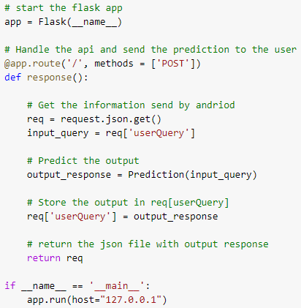

* **Advantages of the Flask: -**

1. Using Flask, we can create our own API’s.
2. We can communicate with the android app and web app.

* **Code Link : -**

1. We used “Spyder IDE” to execute the code but our code is available on Google Colaboratory.
2. Link of the code : - <https://colab.research.google.com/drive/1oFw7HRtZ_Oj_1W8S5tHlvIU08Kt76tS_?usp=sharing>